YUKO MOHRI
ESP
Yuko Mohri
Moré Moré (Leaky): Variations (Flow #1, Flow #2, Flow #3), 2018 (detalle)
Vista de exposición, Pirelli HangarBicocca, Milán, 2025
Cortesía de la artista y Pirelli HangarBicocca, Milán
Foto: Agostino Osio
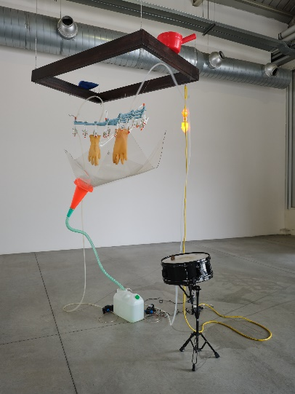
ENG
Yuko Mohri
Moré Moré (Leaky): Variations (Flow #1, Flow #2, Flow #3), 2018 (detail)
Installation view, Pirelli HangarBicocca, Milan, 2025
Courtesy the artist and Pirelli HangarBicocca, Milan
Photo: Agostino Osio

____________________________________________________
ESP
Yuko Mohri
Retrato
Foto: kugeyasuhide
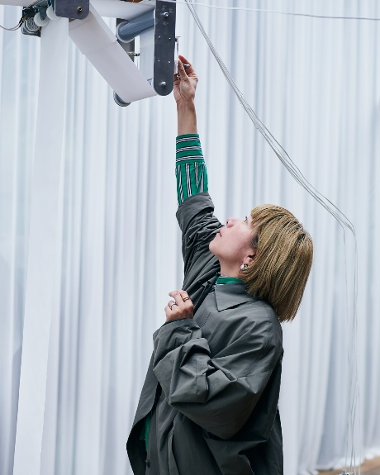
ENG
Yuko Mohri
Portrait
Photo: kugeyasuhide

